Customer Shopping Behavior
SQL Report

-- Q1. What is the total revenue generated by male vs. female customers?
SELECT gender, SUM(purchase_amount)
FROM customer
GROUP BY gender;

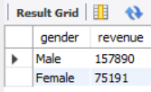

-- Q2. Which customers used a discount but still spent more than the average purchase amount?
SELECT customer_id, purchase_amount
FROM customer
WHERE discount_applied = 'Yes' AND
purchase_amount >= (SELECT AVG(purchase_amount)
FROM customer);

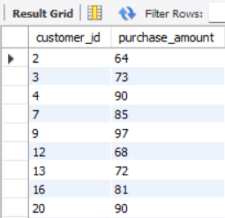
-- Q3. Which are the top 5 products with the highest average review rating?
SELECT item_purchased, ROUND(AVG(review_rating), 2)
FROM customer
GROUP BY item_purchased ORDER BY AVG(review_rating) DESC LIMIT 5;
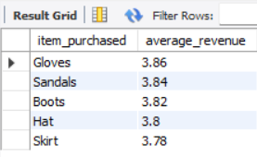

-- Q4. Compare the average Purchase Amounts between Standard and Express Shipping.
SELECT shipping_type,
ROUND(AVG(purchase_amount), 2) AS avg_purchase_amount
FROM customer
GROUP BY shipping_type
HAVING shipping_type IN ('Express' , 'Standard');
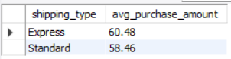

-- Q5. Do subscribed customers spend more? Compare average spend and total revenue
-- between subscribers and non-subscribers.
SELECT subscription_status,
AVG(purchase_amount) AS avg_spend,
SUM(purchase_amount) AS total_revenue
from customer
group by subscription_status;
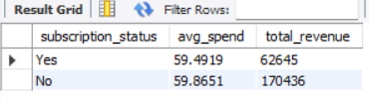

-- Q6. Which 5 products have the highest percentage of purchases with discounts applied?
SELECT item_purchased,
SUM(purchase_amount) AS total_revenue,
SUM(purchase_amount) * 100 / (SELECT SUM(purchase_amount)
FROM customer WHERE discount_applied = 'Yes') AS purchase_pct
FROM customer
WHERE discount_applied = 'Yes'
GROUP BY item_purchased
ORDER BY purchase_pct DESC
LIMIT 5;
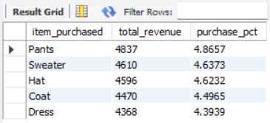

-- Q7. Segment customers into New, Returning, and Loyal based on their total
-- number of previous purchases, and show the count of each segment.
WITH customer_type as(
select case when previous_purchases <=5 then "New "
when previous_purchases <=15 then "Returning "
when previous_purchases >15 then "Loyal "
end as customer_segment
from customer)
select customer_segment, count(*) from customer_type
group by customer_segment;
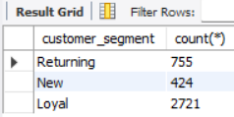

-- Q8. What are the top 3 most purchased products within each category?
WITH item_count as ( select category, item_purchased, count(customer_id) as total_orders,
row_number() over (partition by category order by count(customer_id) Desc) as item_rank
from customer group by category, item_purchased
)
select * from item_count where item_rank <=3;
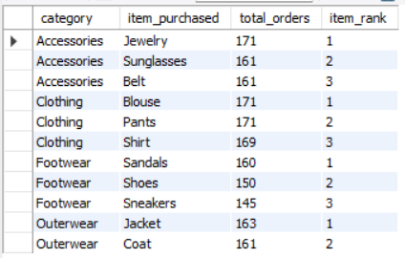

-- Q9. Are customers who are repeat buyers (more than 5 previous purchases) also likely to subscribe?

SELECT COUNT(customer_id) AS total_count, subscription_status
FROM customer
WHERE previous_purchases > 5
GROUP BY subscription_status;
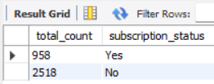

-- Q10. What is the revenue contribution of each age group?
SELECT age_group,
SUM(purchase_amount) AS revenue,
ROUND(SUM(purchase_amount) * 100 / (SELECT SUM(purchase_amount)
FROM customer),2) AS pct_revenue
FROM customer GROUP BY age_group ORDER BY revenue DESC

